Using set operators
- Write a query to display the total salary of each job in departments 10, 20, and 30 in matrix format.
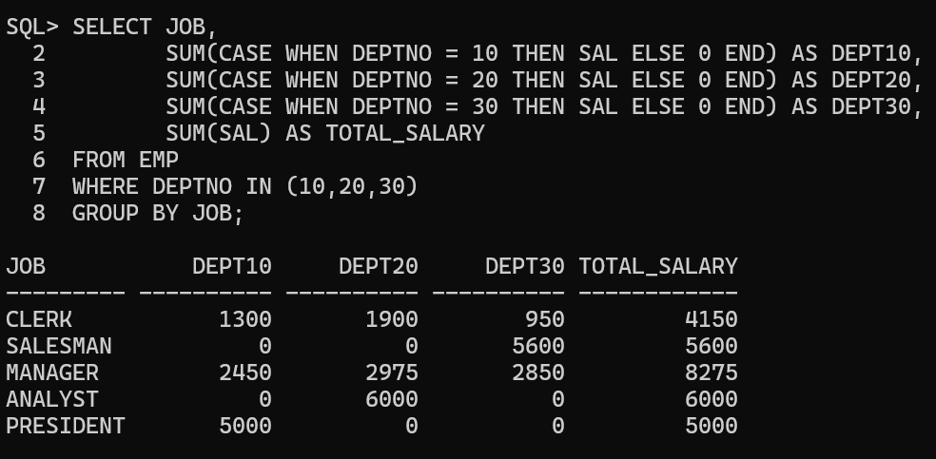

- Write a query using SET operators to display total salary department-wise, job-wise, and the grand total.
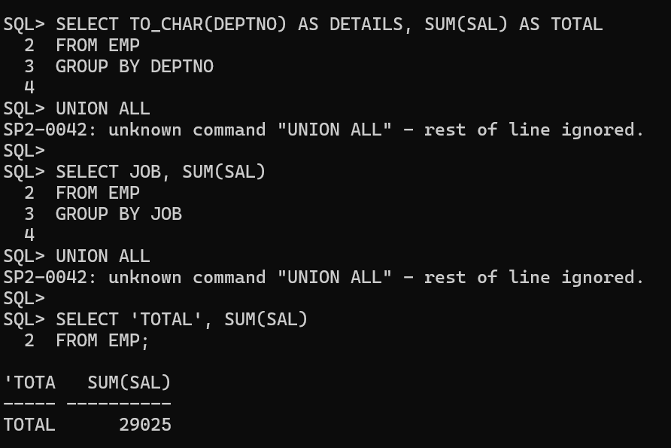

- Write a query using SET operators to display JOB and DEPTNO for departments 10, 20, and 30.
